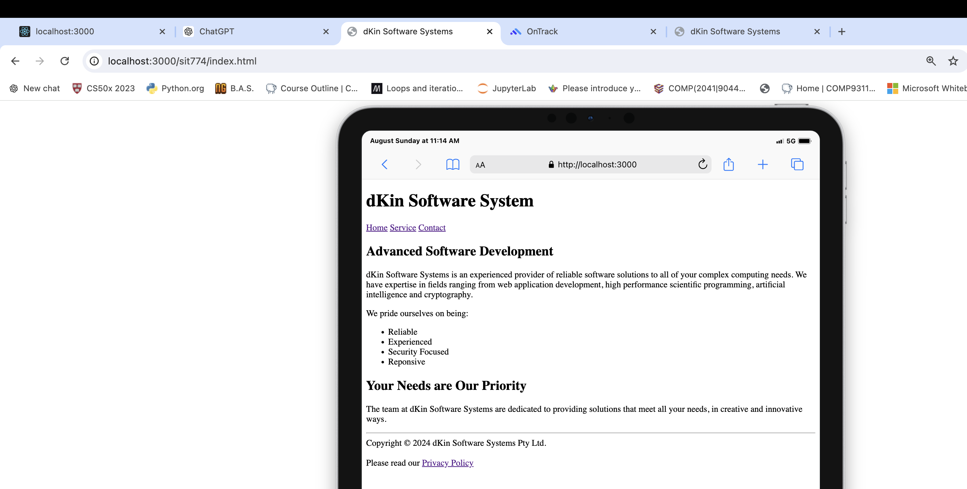

I'm trying to learn how to upload my webpage to the Deakin Server, but the instruction page says I don't have sufficient privileges to access this information.

